Software Requirements Specification

Background
1.1 Introduction
The overall objective of the new Ethiopian national TVET strategy is to create a competent, motivated, adaptable and innovative workforce that plays pivotal roles in the poverty reduction and socio-economic development efforts of the country. Moreover, building an outcome-based TVET system creates access for equal recognition of competences acquired through whatever the means and ways of being competent.
The outcome of training delivered in the system is measured through a process of verification of a candidate’s achieved competence’s, known as occupational/competence assessment. When we say assessment it is not only a TVET graduate’s competence that is to be measured but also that of anyone who wants his/her competences be recognized. A candidate, no matter the way s/he achieved the competence, who has proven competent through assessment is awarded a certificate. This certificate is an official and a nationally recognized proof of the person’s competence in the respective level or unit/s of competence of an occupation.
The NTQF allows national, comprehensive and flexible certification system for the TVET sector as well as the lower and middle-level manpower of the country’s labor. The competence requirements in the different qualification levels of the country’s vast occupational classifications shall be the basis for the assessment and certification in all industry sectors.

The Existing System

Overview of the Existing System
The OCACC organization has given the exam five times and it will continue to give though there have been little change on the procedure each time. At first, the exam will be advertised using media for example, using news paper and internet at their website (www.ocacc.gov.et) etc. There are 11 sectors and 57 occupation at present time and the candidates will registered by filling the registration form on paper in their assigned assessment sector. Then all the registration forms are collected from each assessment sector. After that an IT staff in the organization will insert the data of all the candidates in the registration data base.
After one month the candidates will take the exam in each assessment sector and exam paper will be corrected by employees. Again the result is inserted into result database to prepare result paper. The result will be viewed within 20 days. The competency scale is 50% of the total questions answered, if higher then, the candidate is competent otherwise not competent.

Problems of the Existing System
As we can see on the overview of the existing system is handled more of manually.
- Since the system is handled manually there is high degree of possibility of error to happen. For instance, on correcting the exam paper, on inserting the result into the result database etc.
- It takes a long time to accomplish a task, for instance, for 20,000 candidates it takes, one month for registration part only. Then the candidate takes the exam. It will take about 20 to 30 days to correct and store the result.
- Cost wisely it needs much extended budget. This includes printing exam paper, employee fee especially for the employee enrolled each time the examination take place.
- It needs again a lot of manpower beginning from registration up to the last part which is the result preparation. These are to register the candidates, to insert the information to the database, in the exam time there is supervisor, exam preparing personnel, employees to correct the exam paper, a number of IT professionals to insert data into the database and so on.

The Proposed System
For all the above reasons the existing system is costly in resource and manual labor. It takes a long time and is insecure. So we propose a new automated web based online examination system.

General objective
The main objective of this project work is to automate a web-based examination system that enhances data handling, data processing and data dissemination of COC.

Specific objective
To achieve the proposed system, the following are specific objectives of the project. We
- Develop algorithms or set of rules to solve the problem.
- Prototype to form a preliminary system that has all the necessary features of the final system.
- Validate will be included to make the system produce valid result against any inputs.

Significance of the project
This project is important because it solves the above problems with a computerized system in which there will be a centralized system with networked computers so that there will not be the risk of security, and data redundancy because there will be a secure central server.

Scope of the project
This project is basically focused on the examination for the 10th level students or college student or those who have the experience in a specific field and believe they are competent. It is primarily developed for Addis Ababa region only because there is not enough network infrastructures outside of Addis Ababa.
The examination software will include multiple choice and true false questions only as the existing system. It includes the theoretical part of the examination, the practical to be handled in the examination laboratory. The payment is not online; it is paid manually by a candidate at a nearby bank and receives the unique code to register online.

Methodologies and Techniques
The methodologies and techniques that we chose for the proposal are interview, observation and literature review to get the general information about the existing system. Other sources of information were as Forms, Report, and workflow papers regarding the existing system. We are planning on getting detailed information by preparing brief questionnaires for the requirement analysis and development.

System Analysis and Design and Development Tools
In this project work, for system analysis and design, the team will use object oriented approach because of the following advantages over the structured one.
- Reusability of the code, so the cost and time required for the implementation of the system will be reduced.
- Manage the complexity of the system by abstraction.
- Objects are more accurate in reflecting reality in a model.
In doing so, we use diagrams like use case, class diagram, activity diagram and others for modeling the existing system and the proposed one. Object oriented analysis of the existing system is used to understand the details of the existing system and identify system requirement.The tools that we are using five laptops, Apache (WAMP) sever, web application tool as rational software for modeling, Visio software.

Project Plan

Resource Requirement
At least three laptops, web application tool, rational rose, modeling, Visio software.
Table 5.1 Resource Requirement
Resource | Name | Specification
Laptop
  Toshiba
  Compaq
  Toshiba
  Toshiba
  Dell
  L300,250HD,2GB RAM
  CQ50,250HD,3GB RAM
  L300,250HD,2GB RAM
  L300,250HD,2GB RAM
  Inspiron1525,250HD,2GB RAM
Development resource
  Mozilla Firefox Browser
  Wamp Server
  Windows Operating System
  Macromedia Dream weaver
  Macromedia Flash
  Fire work
  Version 5.0
  Version 2.0
  XP/NT/Vista
  Version 8.0
  Version 8.0
  Version 8.0
Diagram tool | Rational rose | Version 0.96.1

Project cost
We classified the project cost into two; these are hardware and software resource. This is based on the Addis Ababa system of examination. This includes 30000 candidates. The hardware resource cost includes the approximate annual electronic degradation percentile, 20 % of the original price. And deployment cost of computers for each candidate per day. The software resource cost is based on the original software price which can be found in each specific website.

Schedule
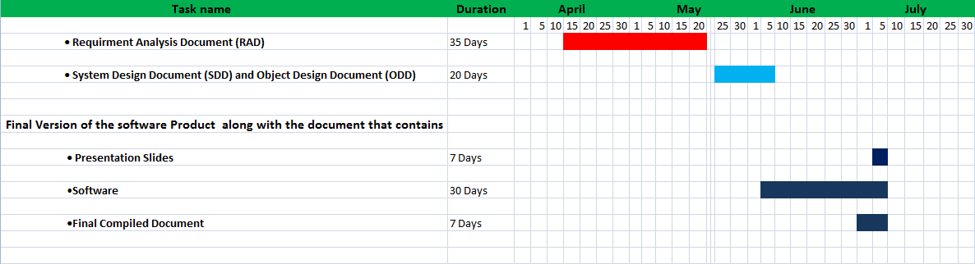
Fig.1 proposed system Schedule

Acronyms
- OCACC Occupational competency assessment and certification center.
- TVET Technical and Vocational Education and Training.
- COC Center of Competence.
- NTQF National TVET Qualification Framework.
- IT Information Technology.

